**LAB 5 Operational Amplifiers**

CSUS Department of Engineering

Author: Ramyasri Singamsetty

Lab Instructor: Professor Sergio Aguilar Rudametkin

Course: EEE 117 Lab

Date: October 17, 2018

* 1. **INTRODUCTION**

This lab focuses on working with operational amplifiers. Operational amplifiers are amplifiers that havea high gain and high input impedances. They are very useful for circuits that require calculations that involve input voltages. This lab works with using operational amplifiers in different types of circuit setups and understanding how they operate.

* 1. **PURPOSE**

The purpose of this lab is to learn and understand how to operational amplifier in different types of circuits. Operational amplifiers are not designed in a very straightforward manner due to their specific input and output pins so setting up circuits involving these amplifiers can be very tricky. This lab also allows us to work with new circuit setups that involve different concepts such as inverting, strain gauge, and weighted summer circuits. Along with setting up these circuits, specific voltage calculations need to be done and this gives more exposure and practice to such calculations.

* 1. **PROCEDURE**

**Part I. Inverting Amplifier**

Part 1 of this lab works with an inverting amplifier and mainly focuses on the importance of the inverting single input voltage configuration. The op-amp used in this portion of the lab is the

μA741 op-amp and is very sensitive to any form of voltages that are not accurate. The following images shows the configuration of the power supply and the schematic of the circuit that we built from.

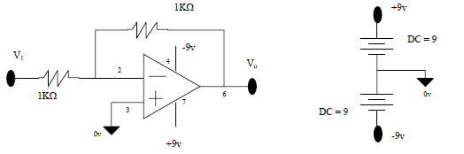

We took note of the fact that the input voltage needs to be 500 Hz with a peak to peak voltage of 3 volts and 0 DC offset. We measured the input and output voltages with both the oscilloscope and the DMM using the following resistance values:

Resistance Values(Specified): Rf = 1 KOhms Rf1= 1 KOhms

Resistance Values(Measured): Rf = 0.991 KOhms R1 = 0.997 KOhms

|  |  |  |
| --- | --- | --- |
| Voltage(RMS) | Oscilloscope | Digital Multimeter |
| V1 | 1.09 VAC | 1.013 VAC |
| Vo | 1.09 VAC | 1.013 VAC |

When comparing the measurements taken by the oscilloscope and the DMM, it can be seen that the input and output voltages are equal to each other (V1 = Vo).

Calculated Gain of Circuit(Specified)

Delta V = Vout/Vin = - Rf/ R1 = - 1 KOhms

Theoretical Gain of Circuit(Measured):

Delta V = Vout/Vin = - 0.991/ 0.997 = - 0.944 KOhms

The relationship between the input and output voltages seems to be a phase relationship of 180 degrees because the output voltage seems to equal the negative value of the input voltage. This can be seen from the measurements taken and the theoretical calculations because

V1 = -Vo.

**Part II. Saturation in the Inverting Amplifier**

Part 2 of this lab also uses an inverting single input voltage configuration but a different circuit is used and shown below. The input signal that was Part 1 is also applied here and the measurements are taken with these settings(input voltage needs to be 500 Hz with a peak to peak voltage of 3 volts and 0 DC offset).

We increased the applied peak to peak voltage until distortion was observed. We observed that the distortion happens in Channel 2 and started to occur at a peak to peak value of 3.7. The reason for this distortion is because it is out of the range of saturation.

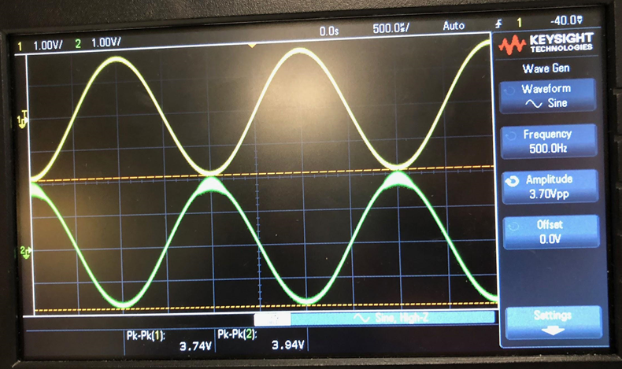

From this, we recorded the following minimum and maximum voltages associated with the input and output voltages.

|  |  |  |
| --- | --- | --- |
| Voltage | V1 | Vo |
| Minimum Voltage | -1.92 Volts | -1.84 Volts |
| Maximum Voltage | 1.82 Volts | 2.1 Volts |

We then reduced the applied input voltage back to 3 volts p-p and applied a DC offset voltage and increased it until a distortion appeared.

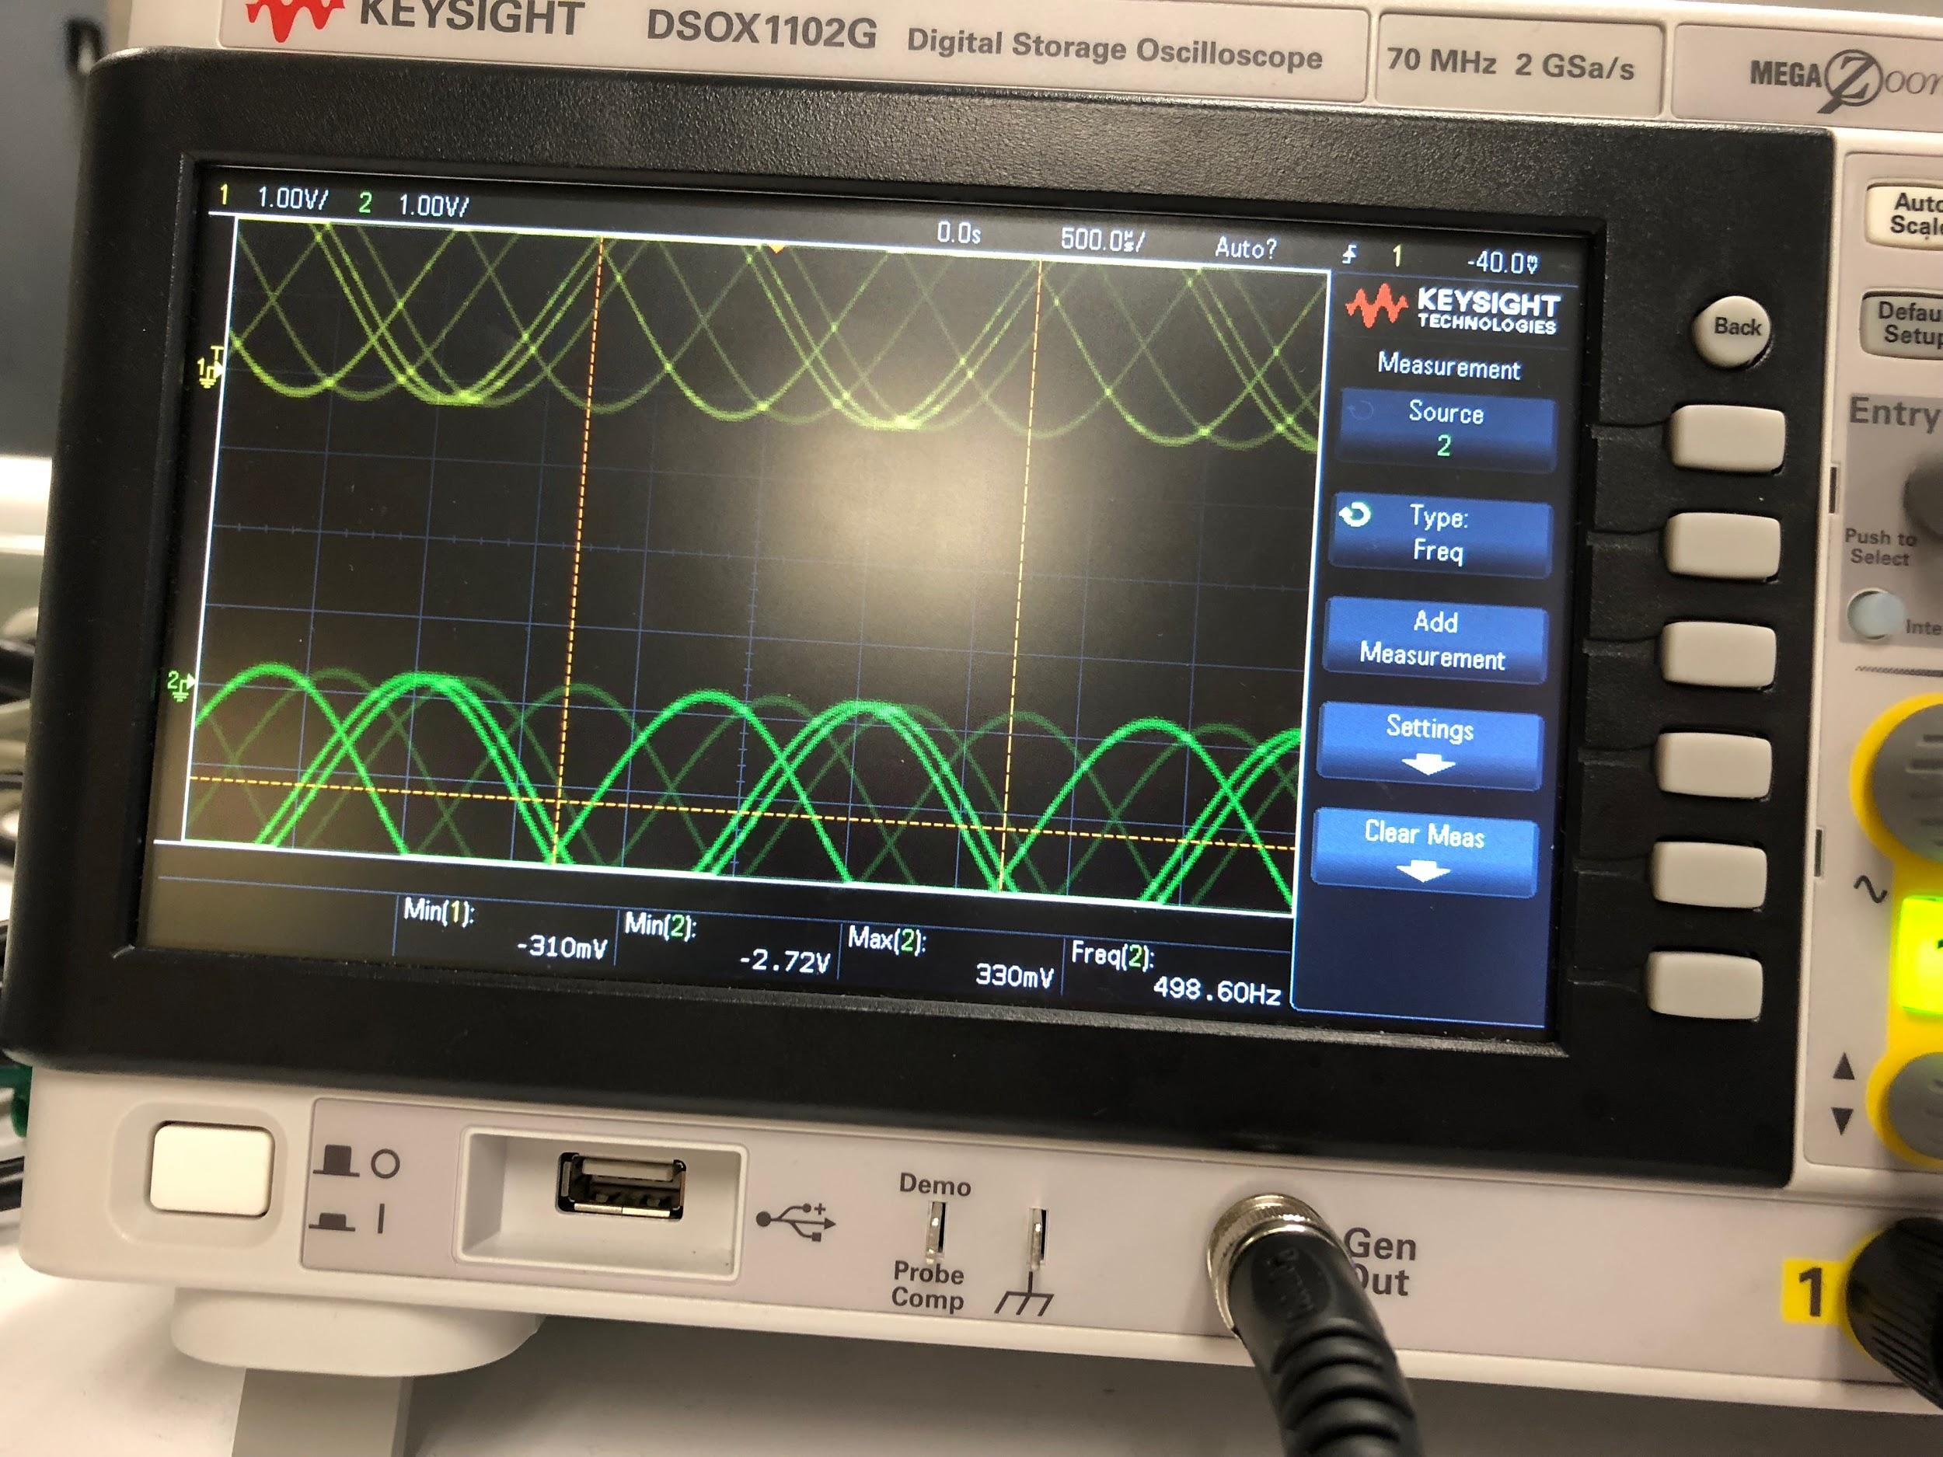

These are following minimum and maximum voltages we observed when the applied input voltage was reduced.

|  |  |  |
| --- | --- | --- |
| Voltage | V1 | Vo |
| Minimum Voltage | -310 mVolts | -2.72 Volts |
| Maximum Voltage | 2.72 Volts | 310 mVolts |

From this, we observed that the distortion appeared starting at a value of 1.3 volts. The distorted voltage was not very close to the +/- 9 input voltage value since the distortion appeared at 1.3 volts.

**PART III. Strain Gauge Amplifier Circuit**

This part of the lab also utilizes the input signal settings used in Part 1 (input voltage needs to be 500 Hz with a peak to peak voltage of 3 volts and 0 DC offset). The following circuit was used to take these measurements:

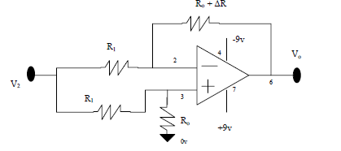

We measured the input and output voltages with both the oscilloscope and the DMM while looking at three different resistors with respect to the circuit shown above:

Looking at resistor: 0.2 KOhms

|  |  |  |
| --- | --- | --- |
| Voltages | Oscilloscope Measurement (V) | Digital Multimeter Measurement (V) |
| V2 | 3.02pp -> rms value = 1.06 | 1.03 (rms) |
| Vo | .28pp -> rms value = .098 | .069 (rms) |

Looking at resistor: 1 KOhms

|  |  |  |
| --- | --- | --- |
| Voltages | Oscilloscope Measurement | Digital Multimeter Measurement |
| V2 | 3.14 pp -> rms value = 1.11 | 1.02 (rms) |
| Vo | 1.05 pp -> rms value = 0.371 | 0.339 (rms) |

Looking at resistor: 4.2 KOhms

|  |  |  |
| --- | --- | --- |
| Voltages | Oscilloscope Measurement | Digital Multimeter Measurement |
| V2 | 3.14 pp -> rms value = 1.11 | 1.03 (rms) |
| Vo | 4.5 pp -> rms value = 1.59 | 1.47 (rms) |

The output voltages in regards to each resistor measurement seem to be smaller than the input voltages being sent in. This observation does not apply to the last resistance measurement because the input voltage was 3.14 volts and the output voltage is 4.5(referencing oscilloscope measurements).

**PART IV. Weighted Summer**

This part of the lab again uses the input signal settings used in Part 1 (input voltage needs to be 500 Hz with a peak to peak voltage of 3 volts and 0 DC offset). We used the following circuit schematic to take the following measurements that involved the digital multimeter and the oscilloscope. For the digital multimeter we only measured the voltage output and for the oscilloscope we measured the average voltage output and the RMS value of the voltage output(AC and DC).

**DMM Measurements:**

|  |  |  |
| --- | --- | --- |
| Voltage | Digital Multimeter Measurement (DC Setting) | Digital Multimeter Measurement (AC Setting) |
| Vo | -1.996V | 0.344V |

**Oscilloscope Measurements:**

|  |  |  |
| --- | --- | --- |
| Voltage | Oscilloscope (AC Coupling) | Oscilloscope (DC Coupling) |
| Average Vo | -2.01 V | -2.04 V |
| RMS Vo | 349.17 mV | 2.07 V |

We also measured the value of the resistors we used to show a more exact representation of our data:

R1 = 0.991 KΩ (resistor that is at the bottom of the circuit schematic)

R1 = 0.994 KΩ

R2 = 2 KΩ

This is the output waveform we observed from the oscilloscope that resulted from a 2-volt peak to peak voltage of 500 Hz:

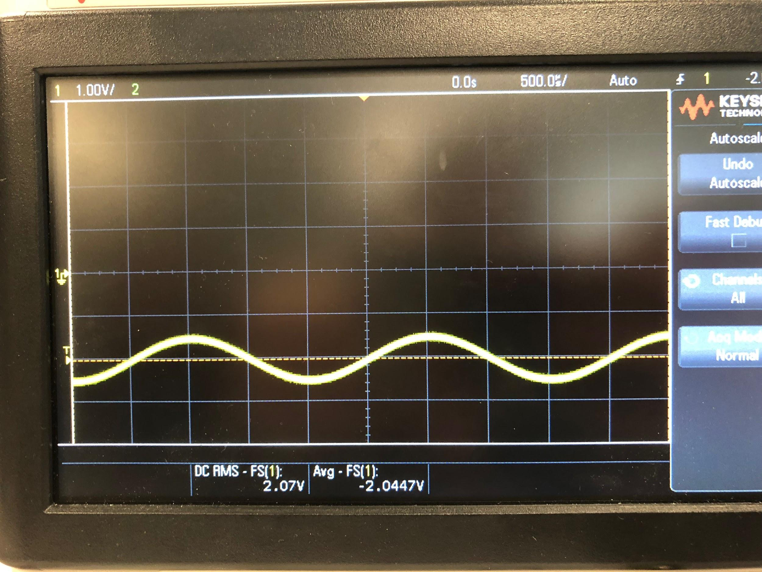

**Conclusion**

I found this lab to be the most difficult of all labs assigned in this course thus far. Each section of the lab had its own specific difficulties in regards to trying to understand it from a conceptual and mathematical perspective. Conceptually I had a general understanding of the functionality of operational amplifiers but I had a very difficult time understanding how to setup the circuits provided involving the operational amplifier. This lab made me realize the importance of understanding how not understanding how to set circuit up can delay the laboratory process. For both parts one and two, my partner and I had to setup the circuit multiple times because we did not understand to translate the schematics provided into a proper setup of our own circuit. This proved to be tricky because op-amps have very specification configuration requirements, so setting up a circuit incorrectly may have caused the op-amp to burn out. From this lab, we also learned the importance of conceptually understanding everything that is involved because if this is not the case, a lot of time is spent in lab deciphering what needs to be done.